DevOps Application Deployment Capstone
GITHUB URL: https://github.com/psakthiece/Devops-build-Project.git
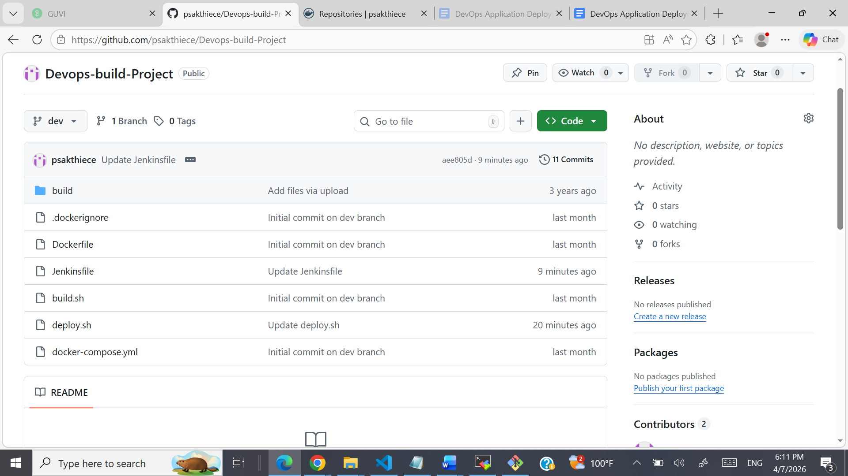

Deployed SITE URL: http://3.238.28.128/


Docker Images uploaded in Docker hub:
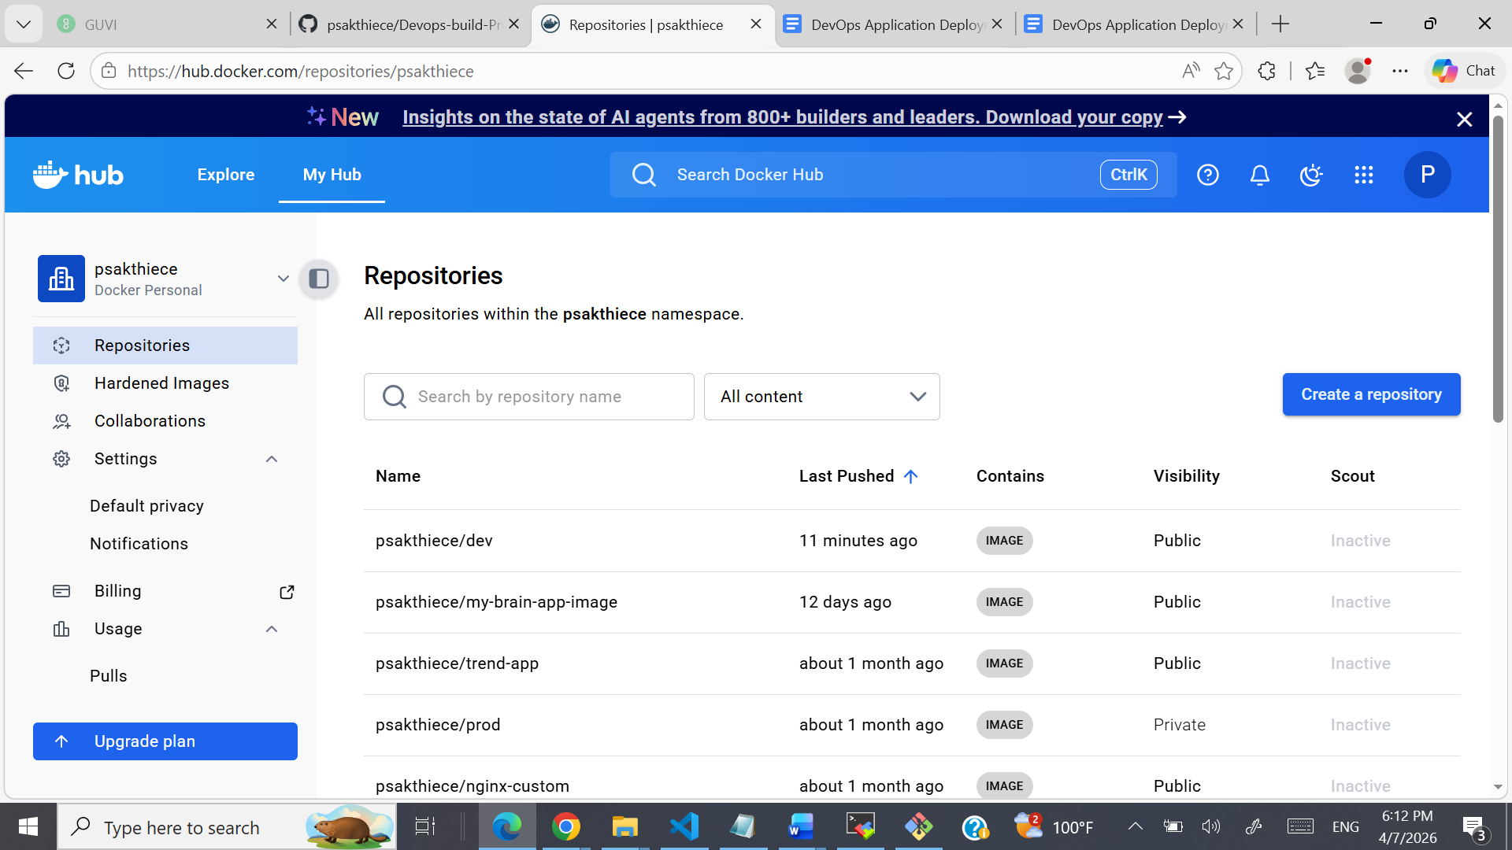
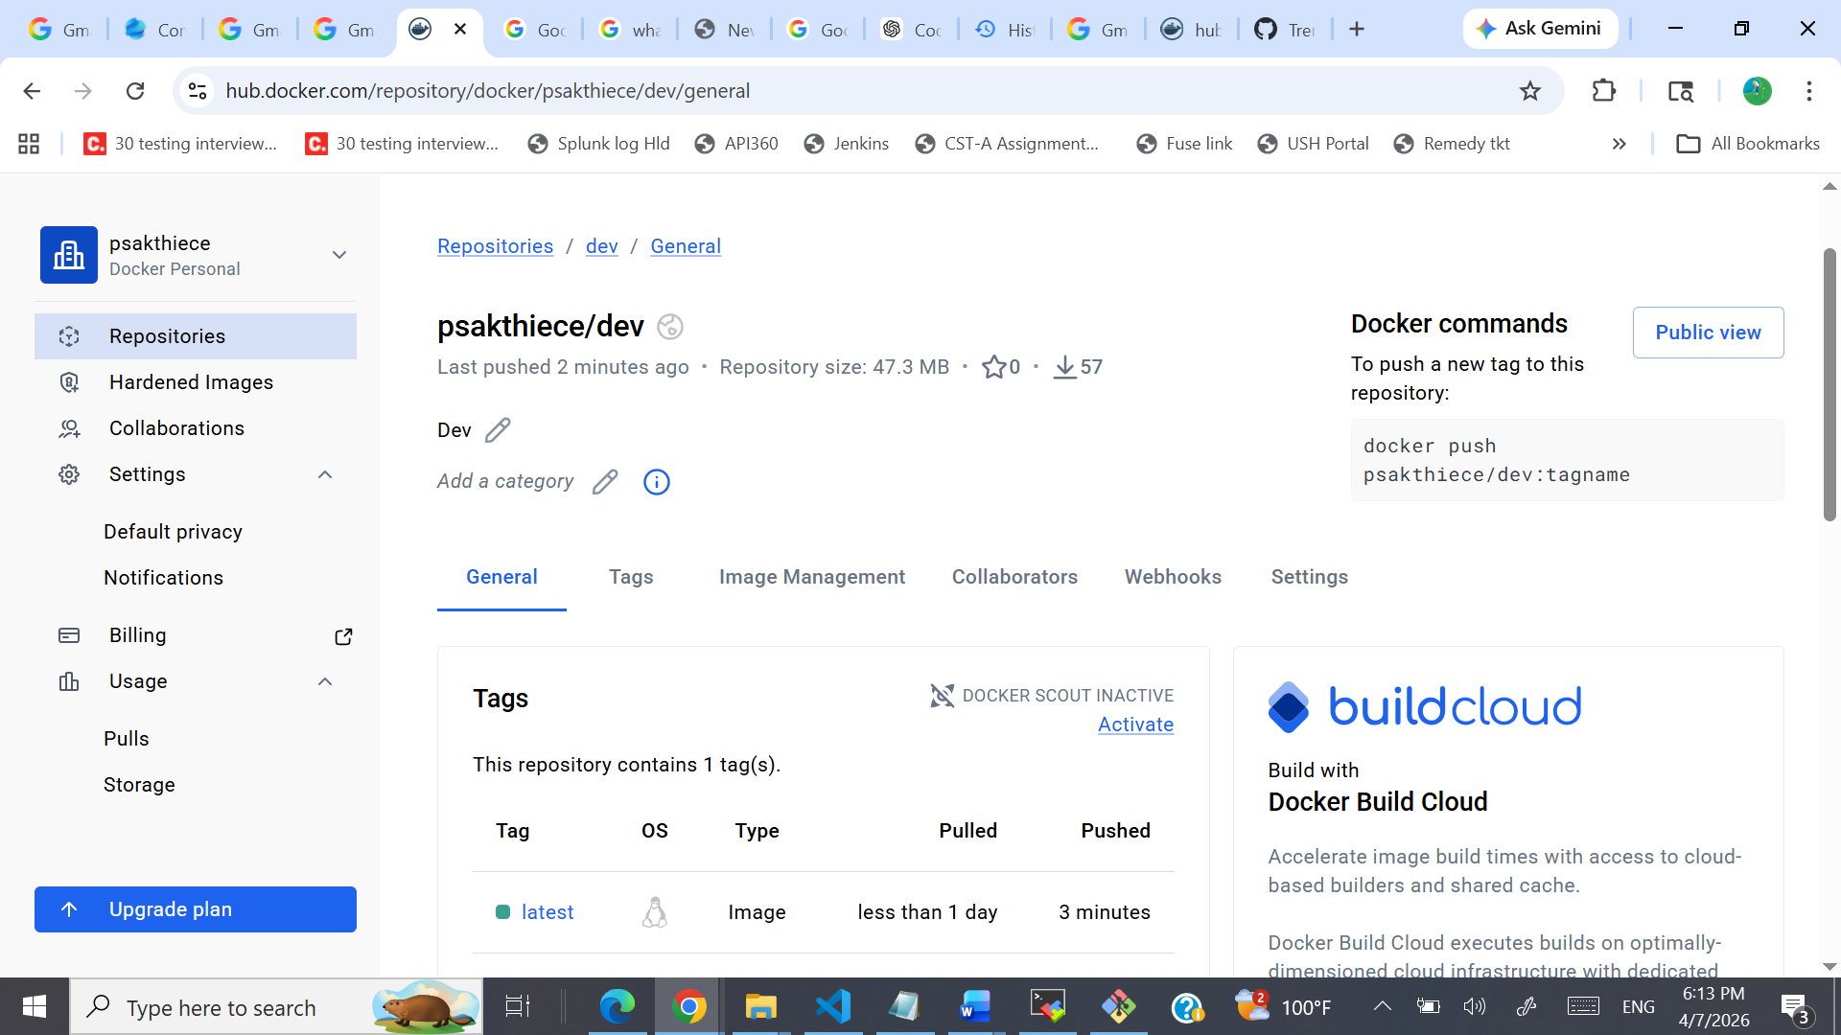
EC2 Instance:
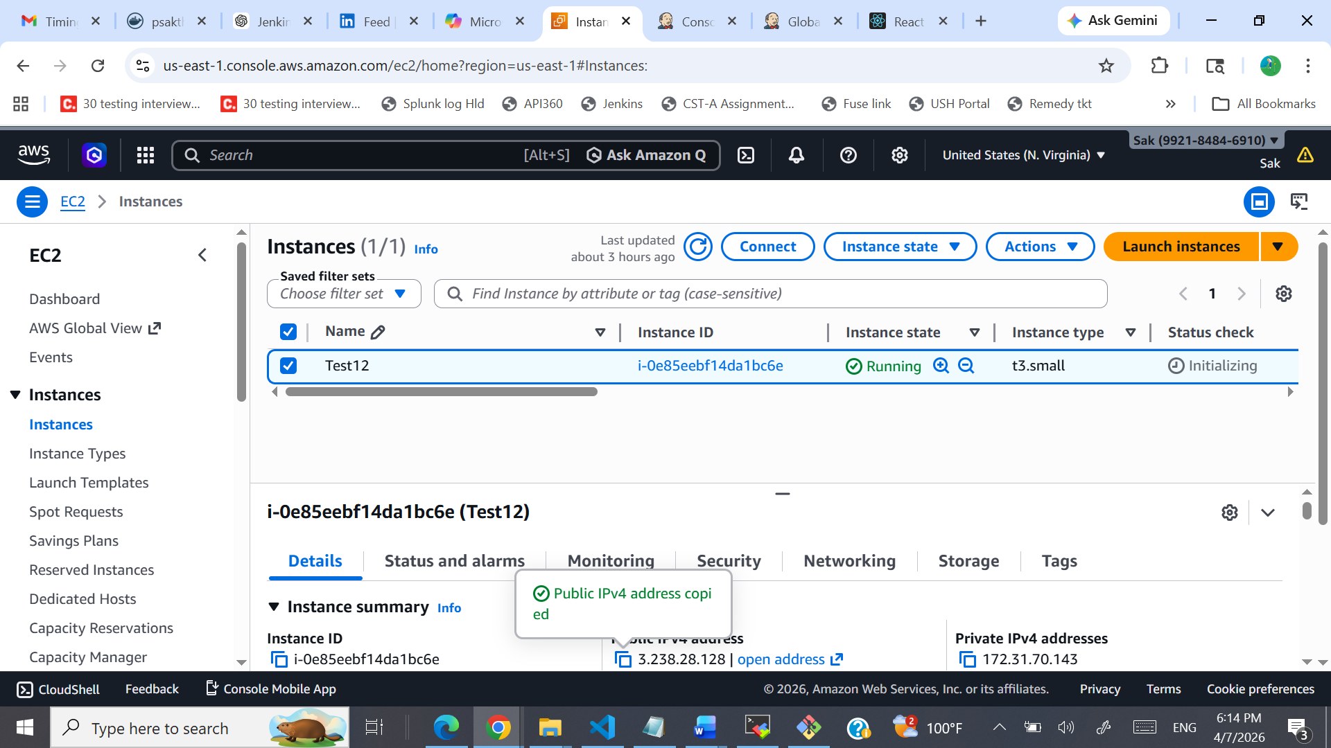
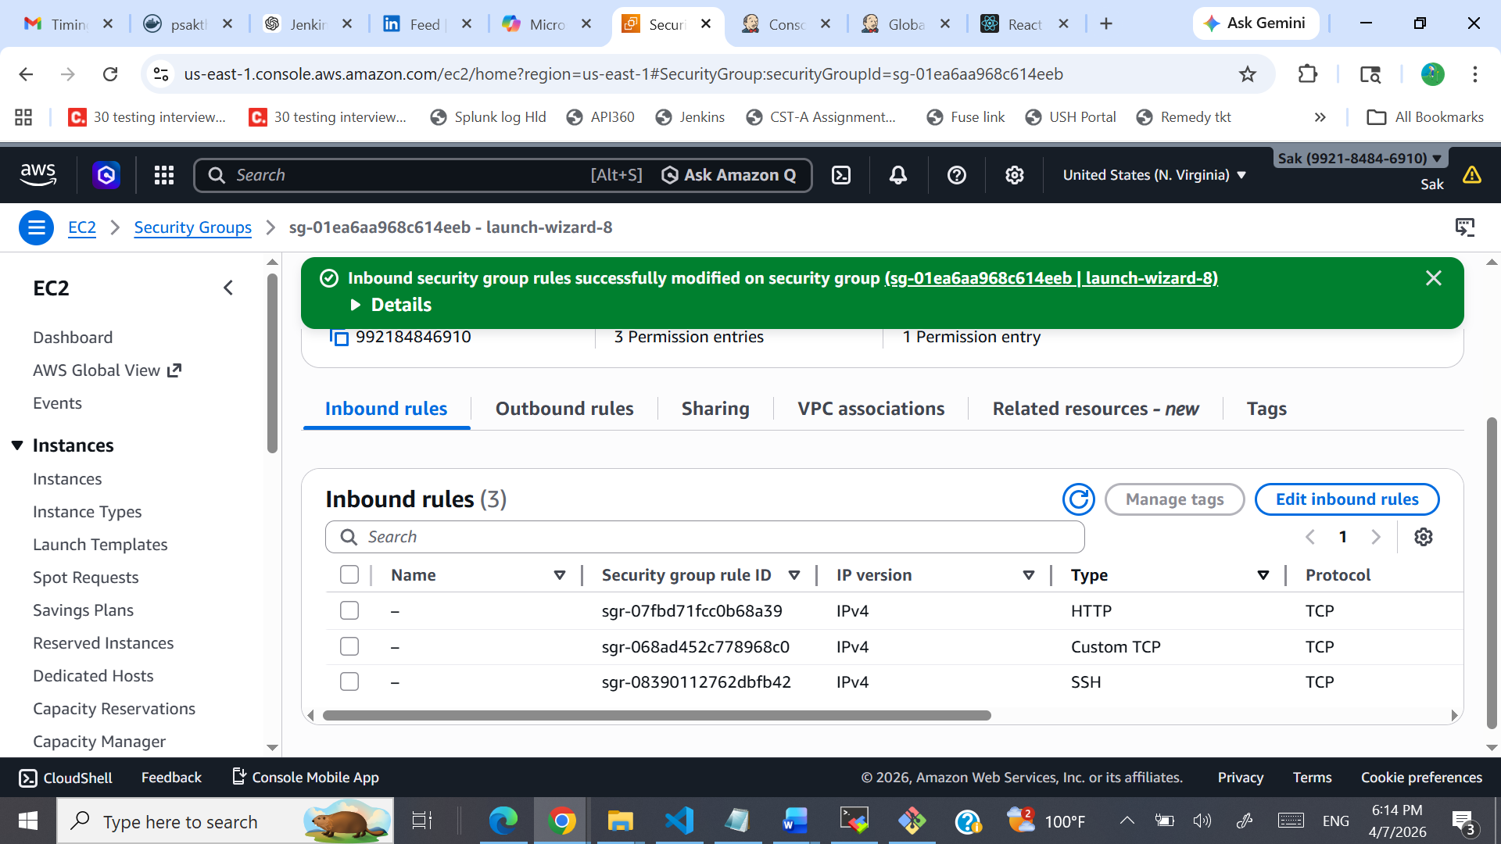

Jenkins :
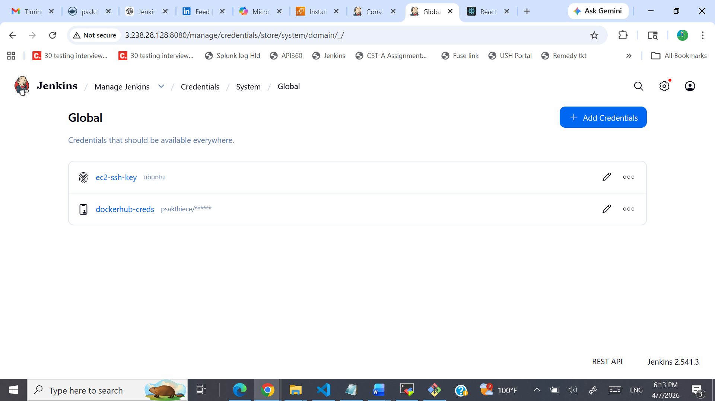

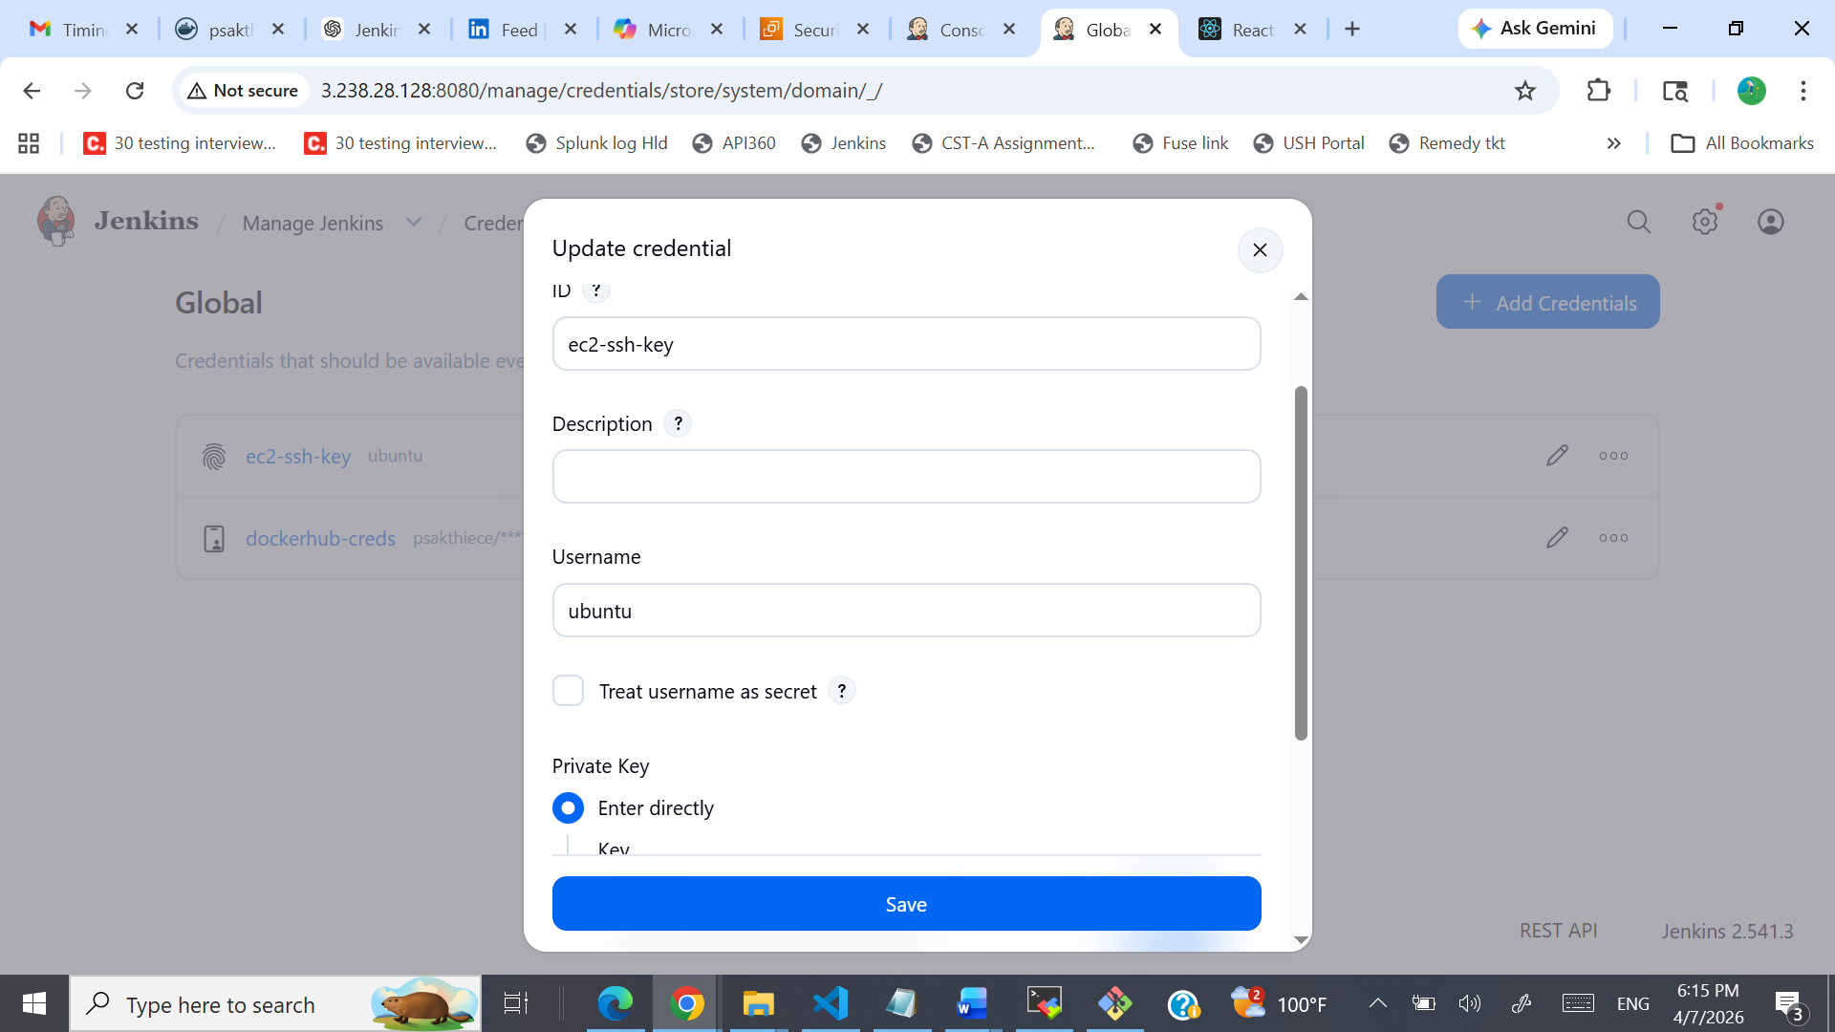
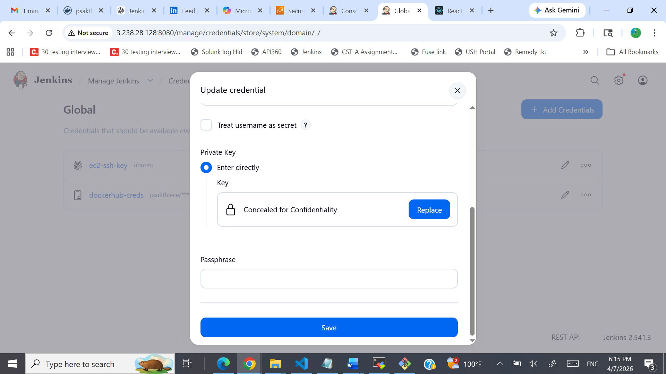
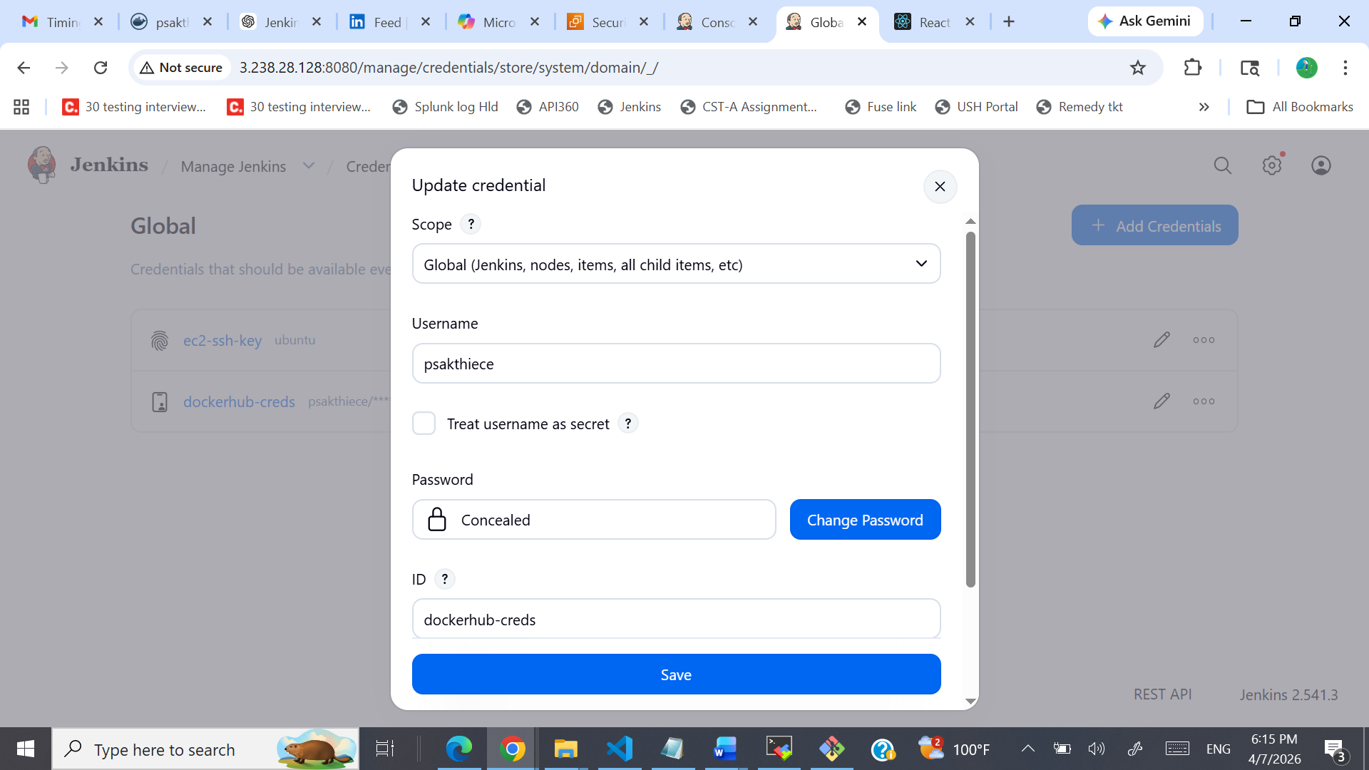
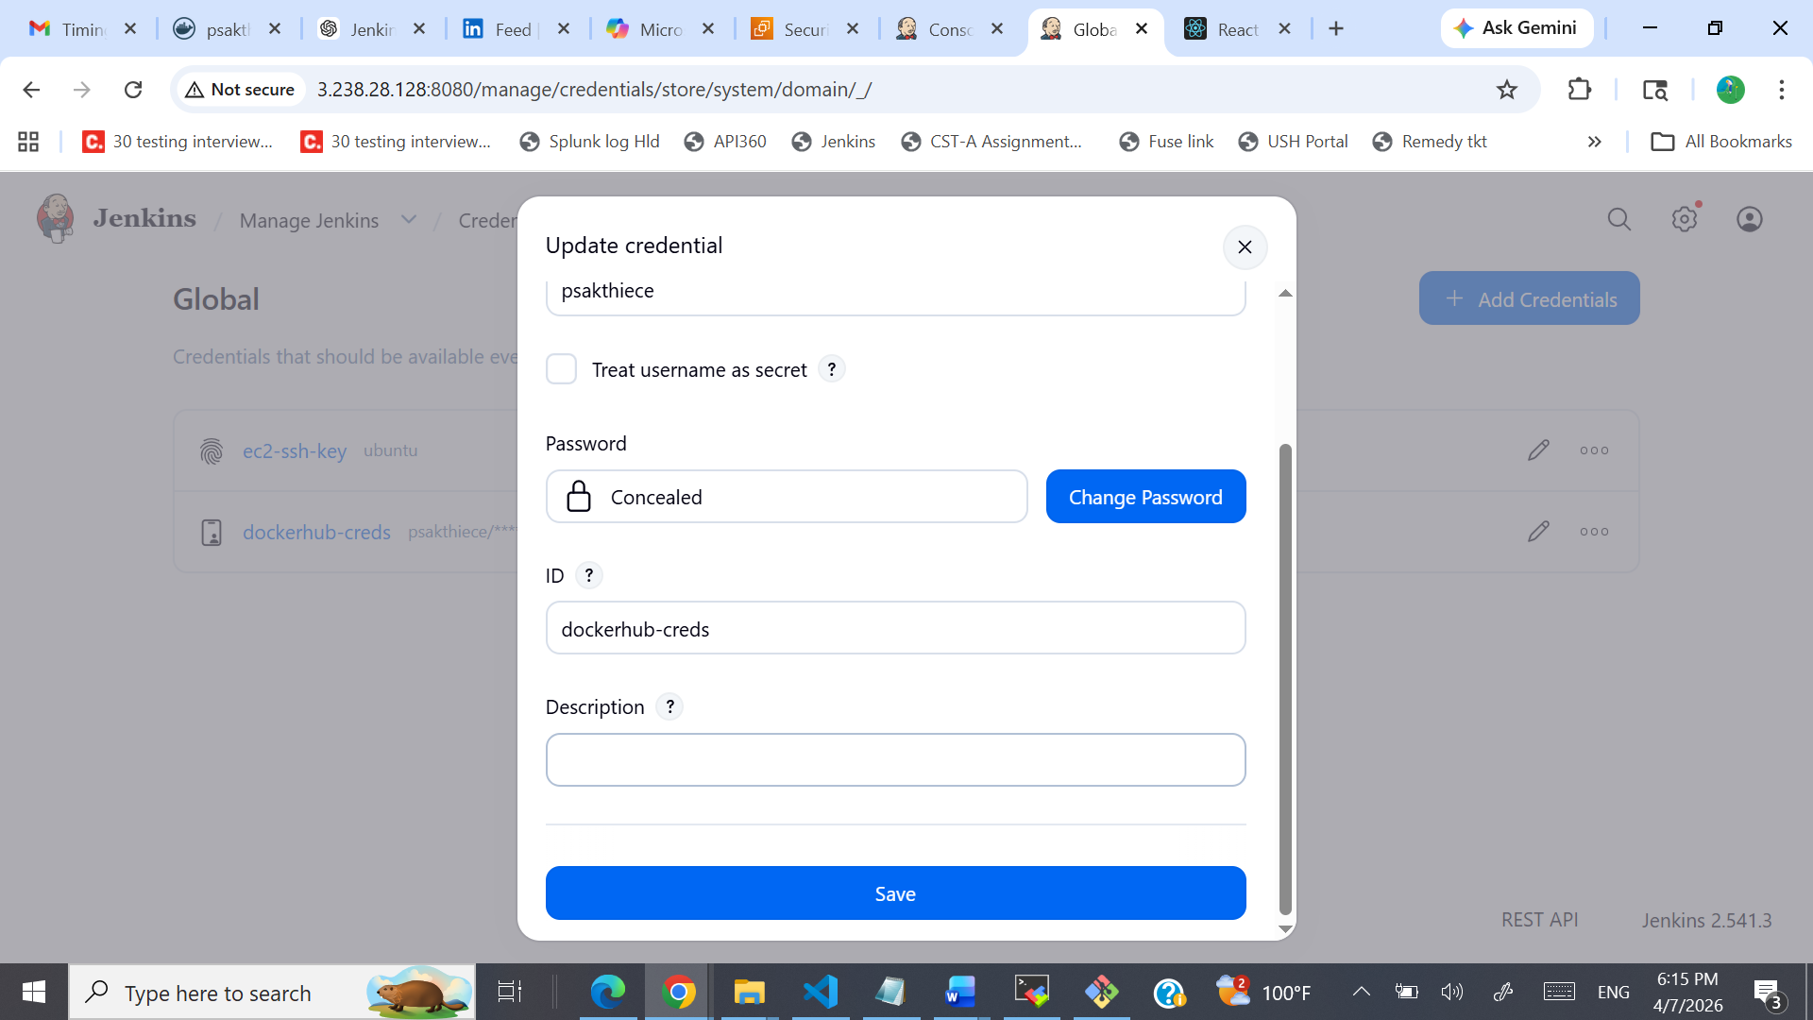

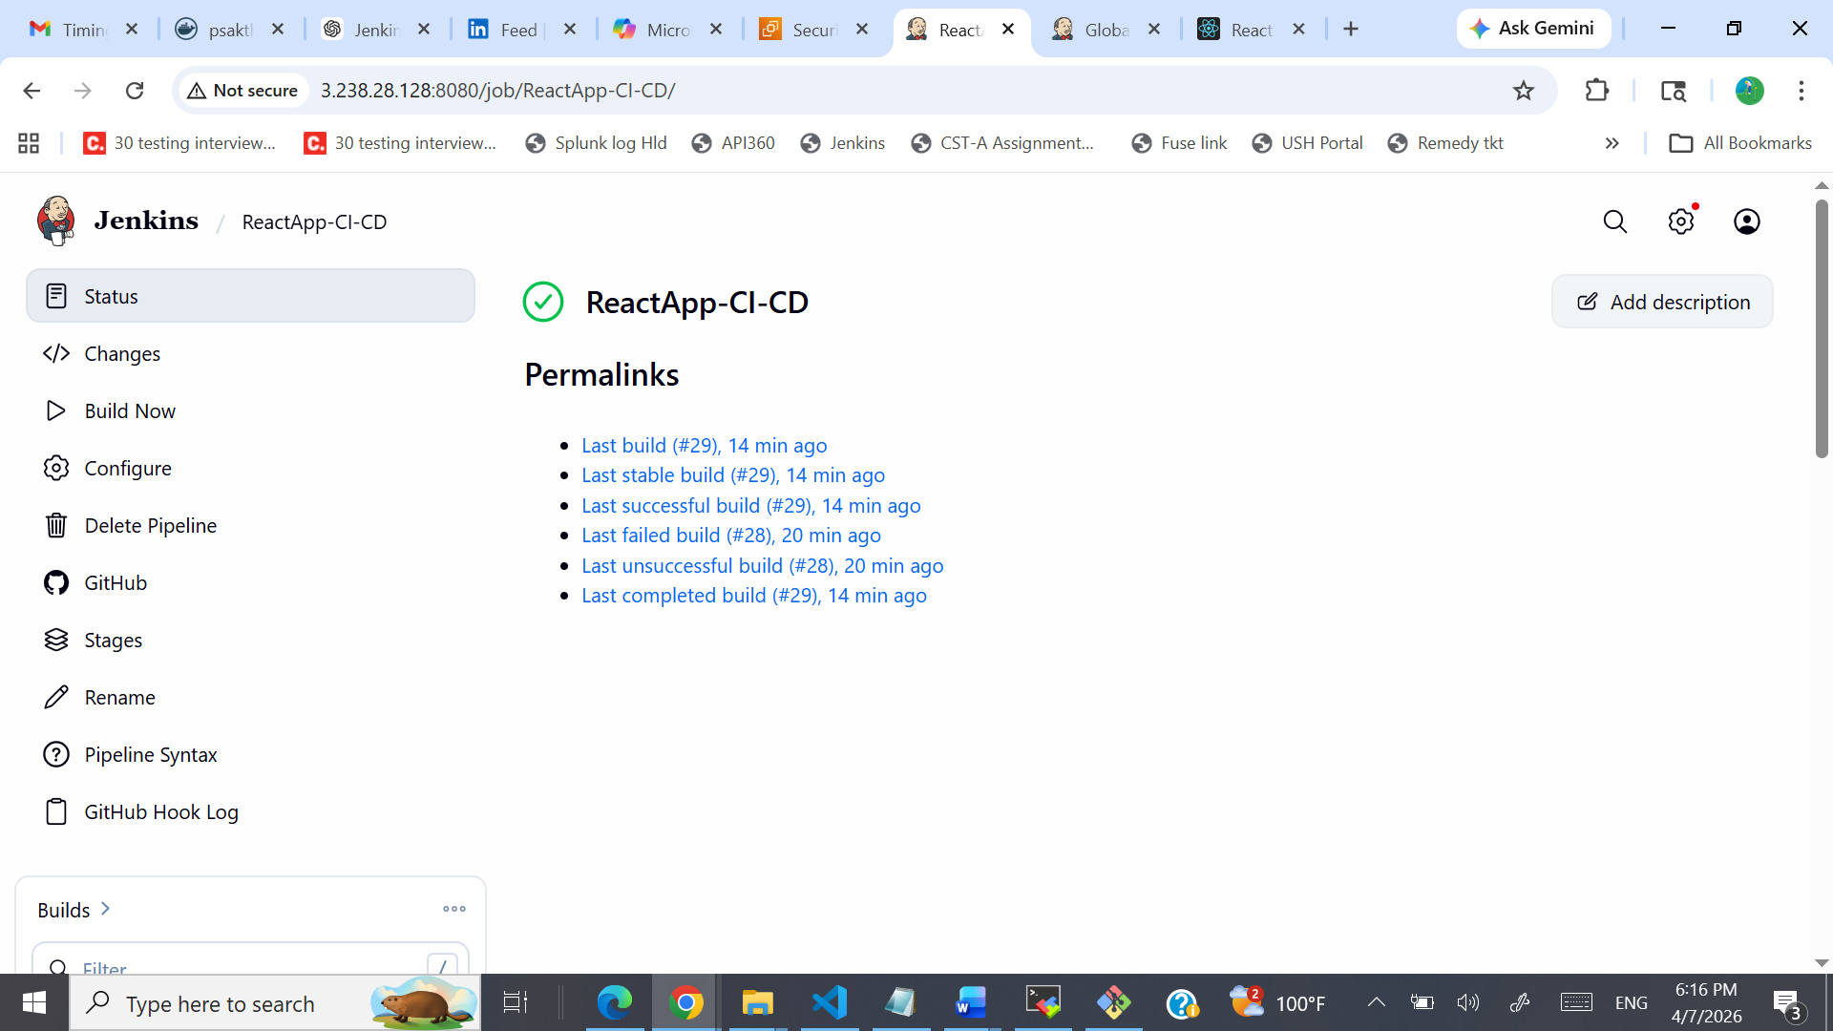

Deployment & health check :
Started by GitHub push by psakthiece
[Pipeline] Start of Pipeline
[Pipeline] node
Running on Jenkins in /var/lib/jenkins/workspace/ReactApp-CI-CD
[Pipeline] {
[Pipeline] withEnv
[Pipeline] {
[Pipeline] stage
[Pipeline] { (Checkout)
[Pipeline] git
The recommended git tool is: NONE
No credentials specified
> git rev-parse --resolve-git-dir /var/lib/jenkins/workspace/ReactApp-CI-CD/.git # timeout=10
Fetching changes from the remote Git repository
> git config remote.origin.url https://github.com/psakthiece/Devops-build-Project.git # timeout=10
Fetching upstream changes from https://github.com/psakthiece/Devops-build-Project.git
> git --version # timeout=10
> git --version # 'git version 2.43.0'
> git fetch --tags --force --progress -- https://github.com/psakthiece/Devops-build-Project.git +refs/heads/*:refs/remotes/origin/* # timeout=10
> git rev-parse refs/remotes/origin/dev^{commit} # timeout=10
Checking out Revision aee805dc1bc96884fec707a8ac3cfabf0a346dc1 (refs/remotes/origin/dev)
> git config core.sparsecheckout # timeout=10
> git checkout -f aee805dc1bc96884fec707a8ac3cfabf0a346dc1 # timeout=10
> git branch -a -v --no-abbrev # timeout=10
> git branch -D dev # timeout=10
> git checkout -b dev aee805dc1bc96884fec707a8ac3cfabf0a346dc1 # timeout=10
Commit message: "Update Jenkinsfile"
> git rev-list --no-walk 093d7f7a828776b9e0fcc6fd79df9f80938b1fce # timeout=10
[Pipeline] }
[Pipeline] // stage
[Pipeline] stage
[Pipeline] { (Build Docker Image)
[Pipeline] sh
+ chmod +x build.sh
[Pipeline] sh
+ ./build.sh
Building Docker image...
DEPRECATED: The legacy builder is deprecated and will be removed in a future release.
Install the buildx component to build images with BuildKit:
https://docs.docker.com/go/buildx/

Sending build context to Docker daemon 2.626MB

Step 1/5 : FROM nginx:alpine
---> d5030d429039
Step 2/5 : RUN rm -rf /usr/share/nginx/html/*
---> Using cache
---> f42e4a30dd24
Step 3/5 : COPY build/ /usr/share/nginx/html/
---> Using cache
---> 0ca27f4b7cd1
Step 4/5 : EXPOSE 80
---> Using cache
---> fb2e05188aad
Step 5/5 : CMD ["nginx", "-g", "daemon off;"]
---> Using cache
---> 002e3f1f3917
Successfully built 002e3f1f3917
Successfully tagged myapp:latest
Build completed!
[Pipeline] }
[Pipeline] // stage
[Pipeline] stage
[Pipeline] { (Push to Docker Hub)
[Pipeline] script
[Pipeline] {
[Pipeline] withCredentials
Masking supported pattern matches of $DOCKER_PASS
[Pipeline] {
[Pipeline] sh
Warning: A secret was passed to "sh" using Groovy String interpolation, which is insecure.
Affected argument(s) used the following variable(s): [DOCKER_PASS]
See https://jenkins.io/redirect/groovy-string-interpolation for details.
+ + docker login -u psakthiece --password-stdin
echo ****
Login Succeeded
[Pipeline] sh
+ docker tag myapp:latest psakthiece/dev:latest
[Pipeline] sh
+ docker push psakthiece/dev:latest
The push refers to repository [docker.io/psakthiece/dev]
d74225922675: Preparing
b464229b9f08: Preparing
6d895dca2a49: Preparing
e8abceee8fd8: Preparing
1eb65b5fb2a1: Preparing
cff742fa7408: Preparing
9ffd725bd2f3: Preparing
8ca391b8823c: Preparing
27fc2bd29afd: Preparing
989e799e6349: Preparing
9ffd725bd2f3: Waiting
8ca391b8823c: Waiting
27fc2bd29afd: Waiting
989e799e6349: Waiting
cff742fa7408: Waiting
6d895dca2a49: Layer already exists
d74225922675: Layer already exists
b464229b9f08: Layer already exists
1eb65b5fb2a1: Layer already exists
e8abceee8fd8: Layer already exists
9ffd725bd2f3: Layer already exists
989e799e6349: Layer already exists
8ca391b8823c: Layer already exists
cff742fa7408: Layer already exists
27fc2bd29afd: Layer already exists
latest: digest: sha256:863e5b4ae3dba67331bb11cda3741b2005045a64e1b07cfe4071719a75b78d6f size: 2406
[Pipeline] }
[Pipeline] // withCredentials
[Pipeline] }
[Pipeline] // script
[Pipeline] }
[Pipeline] // stage
[Pipeline] stage
[Pipeline] { (Deploy to EC2)
[Pipeline] sshagent
[ssh-agent] Using credentials ubuntu
$ ssh-agent
SSH_AUTH_SOCK=/tmp/ssh-16Ikbd5HEa9L/agent.63187
SSH_AGENT_PID=63190
Running ssh-add (command line suppressed)
Identity added: /var/lib/jenkins/workspace/ReactApp-CI-CD@tmp/private_key_16603240077971966821.key (/var/lib/jenkins/workspace/ReactApp-CI-CD@tmp/private_key_16603240077971966821.key)
[ssh-agent] Started.
[Pipeline] {
[Pipeline] sh
+ scp -o StrictHostKeyChecking=no deploy.sh docker-compose.yml ubuntu@3.238.28.128:/home/ubuntu/
+ ssh -o StrictHostKeyChecking=no ubuntu@3.238.28.128 chmod +x ~/deploy.sh && ~/deploy.sh
Deploying application...
time="2026-04-07T12:31:35Z" level=warning msg="/home/ubuntu/docker-compose.yml: the attribute `version` is obsolete, it will be ignored, please remove it to avoid potential confusion"
Container myapp_container Running
Application deployed!
[Pipeline] }
$ ssh-agent -k
unset SSH_AUTH_SOCK;
unset SSH_AGENT_PID;
echo Agent pid 63190 killed;
[ssh-agent] Stopped.
[Pipeline] // sshagent
[Pipeline] }
[Pipeline] // stage
[Pipeline] stage
[Pipeline] { (Health Check)
[Pipeline] script
[Pipeline] {
[Pipeline] sh
+ curl -f http://3.238.28.128
% Total % Received % Xferd Average Speed Time Time Time Current
Dload Upload Total Spent Left Speed

0 0 0 0 0 0 0 0 --:--:-- --:--:-- --:--:-- 0
0 0 0 0 0 0 0 0 --:--:-- 0:00:01 --:--:-- 0
0 0 0 0 0 0 0 0 --:--:-- 0:00:02 --:--:-- 0
0 0 0 0 0 0 0 0 --:--:-- 0:00:03 --:--:-- 0
0 0 0 0 0 0 0 0 --:--:-- 0:00:04 --:--:-- 0
0 0 0 0 0 0 0 0 --:--:-- 0:00:05 --:--:-- 0
0 0 0 0 0 0 0 0 --:--:-- 0:00:06 --:--:-- 0
0 0 0 0 0 0 0 0 --:--:-- 0:00:07 --:--:-- 0
0 0 0 0 0 0 0 0 --:--:-- 0:00:08 --:--:-- 0
0 0 0 0 0 0 0 0 --:--:-- 0:00:09 --:--:-- 0
0 0 0 0 0 0 0 0 --:--:-- 0:00:10 --:--:-- 0
0 0 0 0 0 0 0 0 --:--:-- 0:00:11 --:--:-- 0
0 0 0 0 0 0 0 0 --:--:-- 0:00:12 --:--:-- 0
0 0 0 0 0 0 0 0 --:--:-- 0:00:13 --:--:-- 0
0 0 0 0 0 0 0 0 --:--:-- 0:00:14 --:--:-- 0
0 0 0 0 0 0 0 0 --:--:-- 0:00:15 --:--:-- 0
0 0 0 0 0 0 0 0 --:--:-- 0:00:16 --:--:-- 0
0 0 0 0 0 0 0 0 --:--:-- 0:00:17 --:--:-- 0
0 0 0 0 0 0 0 0 --:--:-- 0:00:18 --:--:-- 0
0 0 0 0 0 0 0 0 --:--:-- 0:00:19 --:--:-- 0
0 0 0 0 0 0 0 0 --:--:-- 0:00:20 --:--:-- 0
0 0 0 0 0 0 0 0 --:--:-- 0:00:21 --:--:-- 0
0 0 0 0 0 0 0 0 --:--:-- 0:00:22 --:--:-- 0
0 0 0 0 0 0 0 0 --:--:-- 0:00:23 --:--:-- 0
0 0 0 0 0 0 0 0 --:--:-- 0:00:24 --:--:-- 0
0 0 0 0 0 0 0 0 --:--:-- 0:00:25 --:--:-- 0
0 0 0 0 0 0 0 0 --:--:-- 0:00:26 --:--:-- 0
0 0 0 0 0 0 0 0 --:--:-- 0:00:27 --:--:-- 0
0 0 0 0 0 0 0 0 --:--:-- 0:00:28 --:--:-- 0
0 0 0 0 0 0 0 0 --:--:-- 0:00:29 --:--:-- 0
0 0 0 0 0 0 0 0 --:--:-- 0:00:30 --:--:-- 0
0 0 0 0 0 0 0 0 --:--:-- 0:00:31 --:--:-- 0
0 0 0 0 0 0 0 0 --:--:-- 0:00:32 --:--:-- 0
0 0 0 0 0 0 0 0 --:--:-- 0:00:33 --:--:-- 0
0 0 0 0 0 0 0 0 --:--:-- 0:00:34 --:--:-- 0
0 0 0 0 0 0 0 0 --:--:-- 0:00:35 --:--:-- 0
0 0 0 0 0 0 0 0 --:--:-- 0:00:36 --:--:-- 0
100 961 100 961 0 0 26 0 0:00:36 0:00:36 --:--:-- 241
<!doctype html><html lang="en"><head><meta charset="utf-8"/><link rel="icon" href="/favicon.ico"/><meta name="viewport" content="width=device-width,initial-scale=1"/><meta name="theme-color" content="#000000"/><meta name="description" content="Web site created using create-react-app"/><link rel="apple-touch-icon" href="/logo192.png"/><link rel="manifest" href="/manifest.json"/><link href="https://cdn.jsdelivr.net/npm/bootstrap@5.1.3/dist/css/bootstrap.min.css" rel="stylesheet" integrity="sha384-1BmE4kWBq78iYhFldvKuhfTAU6auU8tT94WrHftjDbrCEXSU1oBoqyl2QvZ6jIW3" crossorigin="anonymous"><link rel="stylesheet" href="https://cdn.jsdelivr.net/npm/bootstrap-icons@1.10.5/font/bootstrap-icons.css"><title>React App</title><script defer="defer" src="/static/js/main.f1c48542.js"></script><link href="/static/css/main.cf5c13c5.css" rel="stylesheet"></head><body><noscript>You need to enable JavaScript to run this app.</noscript><div id="root"></div></body></html>
[Pipeline] }
[Pipeline] // script
[Pipeline] }
[Pipeline] // stage
[Pipeline] stage
[Pipeline] { (Declarative: Post Actions)
[Pipeline] echo
Deployment successful!
[Pipeline] }
[Pipeline] // stage
[Pipeline] }
[Pipeline] // withEnv
[Pipeline] }
[Pipeline] // node
[Pipeline] End of Pipeline
Finished: SUCCESS

